Node Js

What is Node.js?

* **Node is not a Languages**
* **Node.js is an open source server environment**
* **Node can connect with database but Javascript Not direct**
* **Code & syntex is very similar to javascript but Not exactly same**
* **Node.js is free**
* **Node.js runs on various platforms (Windows, Linux, Unix, Mac OS X, etc.)**
* **Node.js uses JavaScript on the server**
* **Node.js runs the chrome V8 JavaScript engine, the core of Google Chrome, outside of the browser.**

* **Written in c,c++,javascript**

**==============================================================**

* It is a popular tool for almost any kind of project!
* Most useful for create api and also create website
* A Node.js app is run in a single process, without creating a new thread for every request.

* Node.js provides a set of asynchronous I/O primitives in its standard library that prevent JavaScript code from blocking and generally, libraries in Node.js are written using non-blocking paradigms, making blocking behavior the exception rather than the norm When Node.js needs to perform an I/O operation, like reading from the network, accessing a database or the filesystem, instead of blocking the thread and wasting CPU cycles waiting, Node.js will resume the operations when the response comes back.

Why do we use Node.js?

* **Node Mostly used for api create (Fast API WORK)**
* **So we can connect the same database with web app, Mobile App**
* **Node easy because who know javascript**
* **Node super fast for APIs**
* **With Node & Javascript , you can become full stack Developer / Mern Stack**

**====================================================================**

Javascript and Node are same?

* **Javascript and Node.js code syntax is same**
* **If you know javascript then you can learn node very easily**
* **But Both are note same**
* **You can not connect javascript with database**
* **Node js run on server side**
* **Javascript run on browser side**

**===================================================================**

**Topic**

* **Node js Introduction**
* **How works**
* **Install and run**
* **Make basic api**
* **Use with express.js**
* **UI with Node**
  + **UI EVENT**
  + **FORMS**
  + **WEB PAGES**

**====================================================================**

Node.js uses asynchronous programming!

A common task for a web server can be to open a file on the server and return the content to the client.

Here is how PHP or ASP handles a file request:

1. Sends the task to the computer's file system.
2. Waits while the file system opens and reads the file.
3. Returns the content to the client.
4. Ready to handle the next request.

Here is how Node.js handles a file request:

1. Sends the task to the computer's file system.
2. Ready to handle the next request.
3. When the file system has opened and read the file, the server returns the content to the client.

Node.js eliminates the waiting, and simply continues with the next request.

Node.js runs single-threaded, non-blocking, asynchronous programming, which is very memory efficient.

=================================================

What Can Node.js Do?

* Node.js can generate dynamic page content
* Node.js can create, open, read, write, delete, and close files on the server
* Node.js can collect form data
* Node.js can add, delete, modify data in your database

==============================================

What is a Node.js File?

* Node.js files contain tasks that will be executed on certain events
* A typical event is someone trying to access a port on the server
* Node.js files must be initiated on the server before having any effect
* Node.js files have extension ".js"

=================================================

Install and Setup Node JS

* **Download Node**

The official Node.js website has installation instructions for Node.js: [https://nodejs.org](https://nodejs.org/)

* **Install NPM AND NODE  => node js**
* **Code Editors**

**VS CODE**

**Sublime**

**========================================================================**

First Script with Node

Node.js Console/REPL Terminal

Node.js comes with virtual environment called REPL (aka Node shell). REPL stands for Read-Eval-Print-Loop. It is a quick and easy way to test simple Node.js/JavaScript code.

To launch the REPL (Node shell), open command prompt (in Windows) or terminal (in Mac or UNIX/Linux) and type *node* as shown below. It will change the prompt to > in Windows and MAC.

Run : start => node.js

You can also define variables and perform some operation on them.

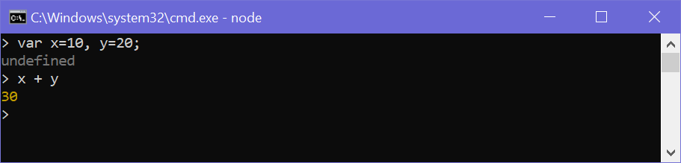

You can execute an external JavaScript file by executing the node fileName command. For example, the following runs mynodejs-app.js on the command prompt/terminal and displays the result.

mynodejs-app.js Copy

console.log("Hello World");

Now, you can execute mynodejs-app from command prompt as shown below.

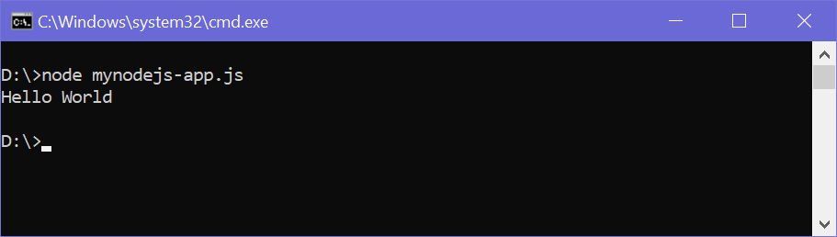

=================================================

Create a Node.js file named "myfirst.js", and add the following code:

Myfirst.js

Code : console.log(‘Hello World’);

Run : node Myfirst

Output : Hello World’

The following table lists important REPL commands.

|  |  |
| --- | --- |
| REPL Command | Description |
| .help | Display help on all the commands |
| tab Keys | Display the list of all commands. |
| Up/Down Keys | See previous commands applied in REPL. |
| .save filename | Save current Node REPL session to a file. |
| .load filename | Load the specified file in the current Node REPL session. |
| ctrl + c | Terminate the current command. |
| ctrl + c (twice) | Exit from the REPL. |
| ctrl + d | Exit from the REPL. |
| .break | Exit from multiline expression. |
| .clear | Exit from multiline expression. |

**Interview Que**

**Que :why its error come in cmd like undefined :**

Ans : Not return anything

**Que :how to different node console & javascript console**

Ans : We write console in cmd its Node build in module & we write in js file console its javascript browser functionality

in node module provide console for debugging

console.log()

console.error()

console.warn()

======================

With File script

Step: 1 Create file **index.js**

**Code file** : console.log(‘Hello world’);

**Run cmd : node index.js**

Node.js Basics

* Node.js supports JavaScript. So, JavaScript syntax on Node.js is similar to the browser's JavaScript syntax.
* Javascript Fundamental for Node.js
* Condition , Loop , Array
* The Import Function and variables from another file

**NodeJS module system**

Modulein Node.js is a simple or complex functionality organized in single or multiple JavaScript files which can be reused throughout the Node.jsapplication Each module in Node.js has its own context, so it cannot interfere with other modules or pollute global scope. Also, each module can be placed in a separate .js file under a separate folder.

1. Core Modules

2. Own Modules or Local Modules

3. NPM Modules or Third Party Module

* 1. **CoreModules**

Core Modules covers minimum functionality of Node.js

These core modules are compiled into its binary distribution and load automatically when Node.js process starts You only need to import the core module first in order to use it in your application

Loading Core Modules

**var module = require('module_name')**

|  |  |
| --- | --- |
| **Module** | **Description** |
| [assert](https://www.w3schools.com/nodejs/ref_assert.asp) | Provides a set of assertion tests |
| [buffer](https://www.w3schools.com/nodejs/ref_buffer.asp) | To handle binary data |
| child_process | To run a child process |
| [cluster](https://www.w3schools.com/nodejs/ref_cluster.asp) | To split a single Node process into multiple processes |
| [crypto](https://www.w3schools.com/nodejs/ref_crypto.asp) | To handle OpenSSL cryptographic functions |
| [dgram](https://www.w3schools.com/nodejs/ref_dgram.asp) | Provides implementation of UDP datagram sockets |
| [dns](https://www.w3schools.com/nodejs/ref_dns.asp) | To do DNS lookups and name resolution functions |
| domain | Deprecated. To handle unhandled errors |
| [events](https://www.w3schools.com/nodejs/ref_events.asp) | To handle events |
| [fs](https://www.w3schools.com/nodejs/ref_fs.asp) | To handle the file system |
| [http](https://www.w3schools.com/nodejs/ref_http.asp) | To make Node.js act as an HTTP server |
| [https](https://www.w3schools.com/nodejs/ref_https.asp) | To make Node.js act as an HTTPS server. |
| [net](https://www.w3schools.com/nodejs/ref_net.asp) | To create servers and clients |
| [os](https://www.w3schools.com/nodejs/ref_os.asp) | Provides information about the operation system |
| [path](https://www.w3schools.com/nodejs/ref_path.asp) | To handle file paths |
| punycode | Deprecated. A character encoding scheme |
| [querystring](https://www.w3schools.com/nodejs/ref_querystring.asp) | To handle URL query strings |
| [readline](https://www.w3schools.com/nodejs/ref_readline.asp) | To handle readable streams one line at the time |
| [stream](https://www.w3schools.com/nodejs/ref_stream.asp) | To handle streaming data |
| [string_decoder](https://www.w3schools.com/nodejs/ref_string_decoder.asp) | To decode buffer objects into strings |
| [timers](https://www.w3schools.com/nodejs/ref_timers.asp) | To execute a function after a given number of milliseconds |
| [tls](https://www.w3schools.com/nodejs/ref_tls.asp) | To implement TLS and SSL protocols |
| tty | Provides classes used by a text terminal |
| [url](https://www.w3schools.com/nodejs/ref_url.asp) | To parse URL strings |
| [util](https://www.w3schools.com/nodejs/ref_util.asp) | To access utility functions |
| v8 | To access information about V8 (the JavaScript engine) |
| [vm](https://www.w3schools.com/nodejs/ref_vm.asp) | To compile JavaScript code in a virtual machine |
| [zlib](https://www.w3schools.com/nodejs/ref_zlib.asp) | To compress or decompress files |

**Exa 1 : http**

**App.js**

var fs=require('fs');

fs.appendFileSync('demo.txt','Hi in am first created file by fs Core module');

**Exa 2 : http**

**var http = require('http');**

**http.createServer((req,resp)=>{**

**resp.writeHead(200, { 'Content-Type': 'text/html' });**

**//resp.write('<h1>Hi i am http module sserver </h1>')**

**resp.write(JSON.stringify({name:"raj",age:31,mobile:"1234567891"}));**

**resp.end();**

**}).listen(5000);**

* 1. **Own Modules or Local Modules**

**Local modules are modules created locally in your Node.js application.**

**These modules include different functionalities of your application in separate**

**files and folders.**

**You can also package it and distribute it via NPM,**

**so that Node.js communitycan use it.**

**We need module.exports to define what couldbe access from other file**

**todatDate.js**

**// this my custome own /local module**

**var todayDate=()=>{**

**var today = new Date();**

**var date = (today.getDate())+'-'+ (today.getMonth()+1) +'-'+(today.getFullYear());**

**return date;**

**}**

**// local module export**

**module.exports = todayDate ;**

**app.js**

// import

var date=require('./todayDate.js');

var result=date();

console.log(result);

/*

* 1. **NPM Modules or Third Party Module**

There are many modules available online which could be used in Node.js.

Node Package Manager (NPM) helps to install those modules, extend them if

necessary and publish them to repositories like Github for access to

distributed machines

To start working with npm module

1. we have to initialize npm in our application

npm init

2. we have to install all module we want to use

npm install validator@versi

==========================================================================================

NPM - Node Package Manager

Node Package Manager (NPM) is a command line tool that installs, updates or uninstalls Node.js packages in your application. It is also an online repository for open-source Node.js packages. The node community around the world creates useful modules and publishes them as packages in this repository.

NPM is included with Node.js installation. After you install Node.js, verify NPM installation by writing the following command in terminal or command prompt

C:\> npm -v

If you have an older version of NPM then you can update it to the latest version using the following command.

C:\> npm install npm -g

To access NPM help, write npm help in the command prompt or terminal window.

C:\> npm help

NPM performs the operation in two **modes: global and local.** In the global mode, NPM performs operations which affect all the Node.js applications on the computer whereas in the local mode, NPM performs operations for the particular local directory which affects an application in that directory only.

Install Package Locally

Use the following command to install any third party module in your local Node.js project folder.

C:\>npm install <package name>

For example, the following command will install ExpressJS into MyNodeProj folder.

C:\MyNodeProj> npm install express

All the modules installed using NPM are installed under node_modules folder. The above command will create ExpressJS folder under node_modules folder in the root folder of your project and install Express.js there.

Add Dependency into package.json

Use --save at the end of the install command to add dependency entry into package.json of your application.

For example, the following command will install ExpressJS in your application and also adds dependency entry into the package.json.

C:\MyNodeProj> npm install express --save

C:\MyNodeProj> npm install express --save

The package.json of NodejsConsoleApp project will look something like below.

Package.json

{

"name": "NodejsConsoleApp",

"version": "0.0.0",

"description": "NodejsConsoleApp",

"main": "app.js",

"author":

{

"name": "Dev",

"email": ""

},

"dependencies":

{

"express": "^4.13.3"

}

}

Install Package Globally

NPM can also install packages globally so that all the node.js application on that computer can import and use the installed packages. NPM installs global packages into */<User>/local/lib/node_modules* folder.

Apply -g in the install command to install package globally. For example, the following command will install ExpressJS globally.

C:\MyNodeProj> npm install -g express

Update Package

C:\MyNodeProj> npm update <package name>

The following command will update the existing ExpressJS module to the latest version.

C:\MyNodeProj> npm update express

Uninstall Packages

C:\>npm uninstall <package name>

C:\MyNodeProj> npm uninstall express

Que : What happened if node_module delete & how load again

ans : npm install

Que :Correct way to push data on git

Ans : create file **.gitignore**  in root dire

.gitignore    add belove code in file means not push beloved folder

/node_module

**Nodemon Package / Time Saving Module**

**All time we have to run node index.js for server run if any changes any file**

Cmd : npm i nodemon -g    globally  in window

          Sudo npm i nodeon -g      in linux

Now Run : **nodemon index.js**  or **nodemon**   and save all time working

**Note : index.js auto take nodemon so not required to write**

**If some securities added in pc then not work globally that time**

Go : search : cmd with administrative then we can done globally

Input get from Command Line

Core Module (process)

process.argv

The process.argv in node is used to access and interact with the command-line arguments.

It is an array that contains the command line arguments and helps user to

interact node app using CLI.

This property returns an array containing the arguments passed to the process

when run in the command line.

process.argv[0]: is the process execution path node

process.argv[1]: is the path for the js file. myfile.txt

process.argv[2] and more: other items in the array are the additional arguments passed by the user.

We can take input from user using command line arguments (process.argv)

node app.js add

- process.argv is Global object like console

console.log(process.argv)

- so we can pass value from command line like what operation we want to perform

node app.js add

0 1 2 3 4 5

cmd go : node app.js raj mahesh nikita nipun // argument start with 0 index

**Example : app.js**

// Importing the process module

const process = require('process');

// Printing process.argv property value

console.log(process.argv);

const data=process.argv;

if(data[2]=="raj")

{

console.log('my name is raj');

}

else if(data[3]=="nikita")

{

console.log('my name is nikita');

}

else

{

console.log('not user');

}

**Yargs : Third party core module : Command Line get & create custom command**

Yargs module is used for creating your own command-line commands in node.js and helps

in generating an elegant user interface. This module makes command-line arguments

flexible and easy to use.

Arguments Parsing with Yargs

Now in above example

node app.js add –title=“This is Title”

This will print same text that we pass through commands

We need to parse the value for that we can use yargs

**npm install yargs@version**

As shown in code snippet for adding note we can also write code for removing note, listing

notes, and reading note similarly

**Example : app.js**

const yargs = require('yargs');

// Create read command

yargs.command({

command: 'read',

describe: 'Read a note',

handler: function () {

console.log('Reading a note')

}

})

Example 2: app.js

// nodemon app.js add --title="Diwali Sale" --body="50% discount on Diwali sale"

const yargs = require('yargs')

// Customize yargs version

yargs.version('1.1.0')

// Create add command

yargs.command({

command: 'add',

describe: 'Add a new note',

builder: {

title: {

describe: 'Note title',

demandOption: true,

type: 'string'

},

body: {

describe: 'Note body',

demandOption: true,

type: 'string'

}

},

handler: function (argv) {

console.log('Title: ' + argv.title)

console.log('Body: ' + argv.body)

}

})

yargs.parse()

**File Management System By : fs module**

Node.js File System (core Module fs )

Node.js includes fs module to access physical file system. The fs module is responsible for all the asynchronous or synchronous file I/O operations.

Let's see some of the common I/O operation examples using fs module.

Common use for the File System module:

Read files

Create files

Update files

Delete files

Rename files

Reading File

fs.readFile(fileName [,options], callback)

Use fs.readFile() method to read the physical file asynchronously.

**Example Read file : app.js**

var fs = require('fs');

fs.readFile('TextFile.txt','utf8', function (err, data)

{

console.log(data);

});

**Example Read file in server: app.js**

/*

Read HTML file on Server

Create a Node.js file that reads the HTML file, and return the content:

*/

var http = require('http');

var fs = require('fs');

http.createServer(function (req, res) {

fs.readFile('demofile1.html','utf8', function (err, data)

{

res.writeHead(200, {'Content-Type': 'text/html'});

res.write(data);

return res.end();

});

}).listen(8080);

=====================================================================================

**File Management CRUD**

Node.js File System / Crud

1) Read

fs.readFile(fileName [,options], callback)

var data = fs.readFileSync('dummyfile.txt', 'utf8');

2) create & Write

fs.writeFile('test.txt', 'Hello World!', function (err))

fs.open('TestFile.txt', 'w', function (err, file)

3) update & write

fs.appendFile('test.txt', 'Hello World!', function (err)

4) delete

fs.unlink('test.txt', function ())

5) Rename

fs.rename(oldPath, newPath, callback)

*/

const fs = require('fs');

/*

fs.writeFileSync('raj.txt','this is a simple file',(err)=>{

if(!err) { console.log("file is created"); }

})

*/

// read

/*

fs.readFile('raj.txt','utf8',(err,data)=>{

console.log(data);

})

*/

// update

/*

fs.appendFile('raj.txt','for fruits',(err)=>{

if(!err) {

console.log("file is updated");

}

})

*/

// rename

/*

fs.rename('raj.txt','rajnew.txt',(err)=>{

if(!err) console.log("file name is updated")

})

*/

// Delete fs.unlink('test.txt', function ())

/*

fs.unlinkSync('rajnew.txt',(err)=>{

if(!err) console.log("file is deleted")

});

*/

**File Management CRUD in Dir (path core module)**

/*

Node.js File System / Crud in dir

core module : path

const path = require('node:path');

const notes = '/users/joe/notes.txt';

path.dirname(notes); // /users/joe

path.basename(notes); // notes.txt

path.extname(notes); // .txt

*/

const fs = require('fs');

//path Core Module

const path = require('path'); // folder module

const dirPath= path.join(__dirname,'myDir'); // current crud folder path

const filePath = `${dirPath}/apple.txt`;

//create file &Write data in myDir folder

/*

fs.writeFileSync(filePath,'this is a simple file',(err)=>{

if(!err) { console.log("file is created"); }

})

*/

// read

/*

fs.readFile(filePath,'utf8',(err,data)=>{

console.log(data);

})

/*

**==============================================**

**File Management CRUD by process.argv**

Example : app.js

var fs = require('fs');

//var data = fs.writeFileSync('dummyfile.txt', 'writecode');

const input=process.argv;

if(input[2]=='add')

{

fs.writeFileSync(input[3],input[4]);

}

else if(input[2]=='read')

{

fs.readFile(input[3],'utf8',(err,data)=>{

console.log(data);

})

}

else if(input[2]=='remove')

{

fs.unlinkSync(input[3]);

}

else

{

console.log('Invalid input');

}

//cmd : node index.js add myfile.txt 'hi hello' // add file

//cmd : node index.js read myfile.txt // read file

//cmd : node index.js remove myfile.txt // remove file

**Nodemon Package / Time Saving Module**

**All time we have to run node index.js for server run if any changes any file**

Cmd : npm i nodemon -g    globally  in window

          Sudo npm i nodeon -g      in linux

Now Run : **nodemon index.js**  or **nodemon**   and save all time working

**Note : index.js auto take nodemon so not required to write**

**If some securities added in pc then not work globally that time**

Go : search : cmd with administrative then we can done globally

**Object Destructuring**

const user = {

    'name': 'Alex',

    'address': '15th Park Avenue',

    'age': 43

}

**const { name, age } = user;**

console.log(name, age); // Output, Alex 43

=============================================================================================

**Asynchronous and Synchronous**

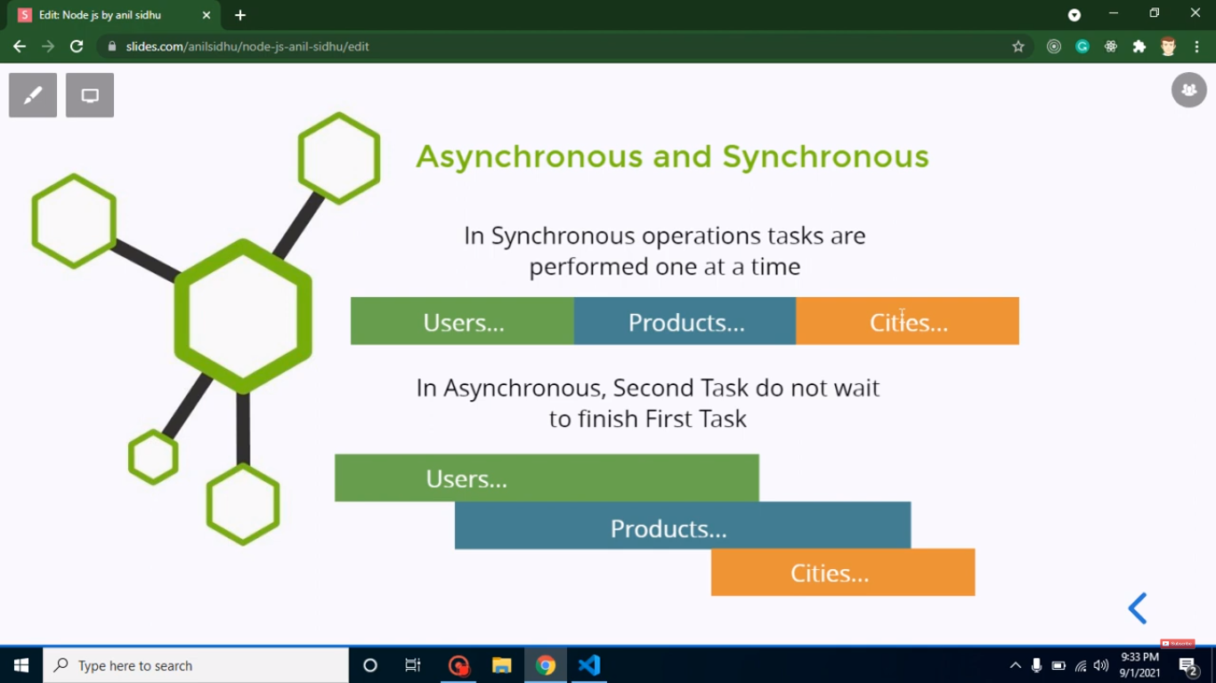

Int Que: node is sync or async  language

Ans : async

4 all stript run together

**If 1 run & then 2 run and if 3 has problem then stop for 3 then 4 run that's called sync**

But In node :

**If 1 run & then 2 run and if 3 has problem then not wait for 3 , next 4 run and after last 3 run**

So not wait in running so its super fast Node js

Example

let a=20;

let b=0;

setTimeout(()=>{

   b=30;

},2000)

console.log(a+b)

**Handel_Async by Promise**

let a=20;

let b=0;

let waitingData= new Promise((resolve,reject)=>{

   setTimeout(()=>{

      resolve(30);

   },2000)

})

waitingData.then((result)=>{

   b=result;

   console.log(a+b)

})

What is Callback?

Callback is an asynchronous equivalent for a function. A callback function is called at the completion of a given task. Node makes heavy use of callbacks. All the APIs of Node are written in such a way that they support callbacks.

Blocking Code Example

Create a text file named input.txt with the following content −

Tutorials Point is giving self learning content

to teach the world in simple and easy way!!!!!

Create a js file named main.js with the following code −

var fs = require("fs");

var data = fs.readFileSync('input.txt');

console.log(data.toString());

console.log("Program Ended");

Now run the main.js to see the result −

$ node main.js

Verify the Output.

Tutorials Point is giving self learning content

to teach the world in simple and easy way!!!!!

Program Ended

Non-Blocking Code Example

Create a text file named input.txt with the following content.

Tutorials Point is giving self learning content

to teach the world in simple and easy way!!!!!

Update main.js to have the following code −

var fs = require("fs");

fs.readFile('input.txt', function (err, data) {

   if (err) return console.error(err);

   console.log(data.toString());

});

console.log("Program Ended");

Now run the main.js to see the result −

$ node main.js

Verify the Output.

Program Ended

Tutorials Point is giving self learning content

to teach the world in simple and easy way!!!!!

**What is Chaining in Node.js ?**

Chaining in Node.js can be achieved using the async npm module. In order to install the async module, we need to run the following script in our directory:

npm init

npm i async

There are two most commonly used methods for chaining functions provided by the async module:

* **parallel(tasks, callback):** The tasks is a collection of functions that runs parallel in practice through I/O switching. If any function in the collection tasks returns an error, the callback function is fired. Once all the functions are completed, the data is passed to the callback function as an array. The callback function is optional.
* **series(tasks, callback)**: Each function in tasks run only after the previous function is completed. If any of the functions throw an error, the subsequent functions are not executed and the callback is fired with an error value. On completion of tasks, the data is passed into the callback function as an array.

**Example 1: Parallel Chaining**

**Filename: index.js**

const async = require('async');

async.parallel([

(callback) => {

setTimeout(() => {

console.log('This is the first function');

callback(null, 1);

}, 500);

},

(callback) => {

console.log('This is the second function');

callback(null, 2);

}

], (err, results) => {

if (err) console.error(err);

console.log(results);

});

**Cmd: node index.js**

**Output:**

**This is the second function**

**This is the first function**

**[ 1, 2 ]**